After watching the Tedx video, what were some of the essential elements of student-centered learning that Ms. Postelnek mentioned? Have you ever found yourself in a situation like she had described about the school in Israel? Why is it important that teachers focus on student centered learning?

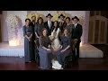
Watch Video
The Power of Potential: Student Centered Learning | Ayla Postelnek | TEDxYeshivaUniversity
Duration: 14:46
User: n/a - Added: 12/18/17

